**Project Deliverable – II**

**Requirements & Design Report**

**for**

**Project Title**

**WhatsUrSay?**

**Prepared By**

**Abhinav Bhandaram**

**Sreedevi Koppula**

**Nikhitha Kaza**

**Rajashekar Korakoppula Goud**

**Organization**

**CSCE 5430: Software Engineering**

**Team**

**Sreedevi Koppula**

**Nikhitha Kaza**

**Rajashekar Korakoppula Goud**

**Abhinav Bhandaram**

**Table of Contents**

**1. Introduction………………………………………………………………………………....... 3**

1.1 Purpose 3

1.2 Document Conventions 3

1.3 Intended Audience and Reading Suggestions 3

1.4 Project Scope 3

**2. Overall Description 4**

2.1 Product Perspective 4

2.2 Product Features 4

2.3 User Classes and Characteristics 4

2.4 Operating Environment 4

2.5 Assumptions and Dependencies 4

**3. System Features 5**

3.1 Create Poll 5

3.2 Create Survey 4

3.3 Create User Group 6

3.4 Add User to User Group 6

3.5 Remove User from User Group 7

3.6 Edit User Group 7

3.7 Delete User Group 8

3.8 Participate in Poll/Survey 8

3.9 Request for Group Leadership 9

3.10 Respond to Group Leadership Request 9

3.11 View Poll Results 9

3.12 Publish Results 10

3.13 Create Admin 11

3.14 Register 11

3.15 Sign In 11

3.16 Forgot Password 12

3.17 Sign Out 12

**4. External Interface Requirements 13**

4.1 User Interfaces 13

4.2 Hardware Interfaces 15

4.3 Software Interfaces 15

4.4 Communications Interfaces 15

**5. Nonfunctional Requirements 15**

5.1 Performance Requirements 15

5.2 Safety Requirements 16

5.3 Security Requirements 16

5.4 Software Quality Attributes 16

**6. Test Plan 16**

**7. System Architecture………………………………………………………………………….29**

**8. UML Design Documents……………………………………………………………………..30**

8.1 Class Diagram……………………………………………………………………………………..30

8.2 Sequence Diagram………………………………………………………………………...............31

8.3 Use Case Diagram………………………………………………………………………................32

**9. Risk Management……...……………………………………………………………………..32**

**10. Project Plan……..……...……………………………………………………………………33**

**11. Meeting Minutes..……...……………………………………………………………………34**

**12. Progress Report……………………………………………………………………………..37**

**13. Member Contribution Table……………………………………………………………….38**

**Appendix………………………………………………………………………………………...41References……………………………………………………………………………………….41**

1. **Introduction**
   1. **Purpose**

“What’sUrSay?” is an online polling and survey system. It enables the authorized users to create polls and surveys within the system, create and maintain user groups in the system, delete user groups from the system, publish the poll results and view the results of polls. This is version one (v1.0) of our product.

* 1. **Document Conventions**

Each functional requirement is uniquely identified in the following format:

REQ-<section-num>.<sub-section-num>.<requirement-num>

If any sub-functional requirement exists, it is identified as:

REQ-<section-num>.<sub-section-num>.<requirement-num>.<sub-reqirement-num>

Ex: If section number of the functional requirements in the document is 1, then the naming is as follows:

REQ-1.1.1

REQ-1.1.2

REQ-1.1.3

REQ-1.1.3.1

REQ-1.1.3.2

REQ-1.1.4

and so on.

Italicized text has been used to highlight document fields in requirements.

Tables and Figures have been given titles to make the user better understand the purpose of them.

* 1. **Intended Audience and Reading Suggestions**

This document is intended for

* Stake Holders
* Managers
* Developers
* Consultants
* Clients
  1. **Project Scope**

A centralized place for all the polling and survey needs of an organization. Users can create, update, participate and delete polls/surveys. Public/Private polls/surveys. Polls/Surveys can be public i.e. open to all for participation or private polls/surveys open for a specific group of users. Polls/Surveys are related to a category. Dashboard view of all polls/surveys. Some polls/surveys or feedbacks are still being conducted using papers.

WhatUrSay would provide an easy and user friendly way to create, participate and result publishing of polls/surveys. It can also be used to create feedback surveys. Anonymous participation option.

1. **Overall Description**
   1. **Product Perspective:**

WhatsUrSay? Is a new web application being developed to satisfy all the polling and survey needs of an organization. This release would be the first release of the application. The application is independent and self-contained. More information on the system and design is provided in section 8.

* 1. **Product Features**

Below outlined are some important features that the scope of our project encompasses:

* Registration form
* Dashboard for each user
* Public and Private Polls/Surveys
* Results on dashboard
* Notifications to the users
* Visualization of the results
* Create new Poll/Surveys.
  1. **User Classes and Characteristics**

The different types of User Classes that our application uses are:

* Root Admin: Creating admin, creating polls/surveys, providing group leader access etc.
* Admin (A): Creating polls/surveys, providing group leader access etc.
* Group leader (L): Creating polls/surveys, Creating/Editing/Deleting user groups etc.
* Normal User (U): Participation in Polls/Surveys, Requesting group leader access etc.
  1. **Operating Environment**

Our product will operate in any environment that contains the below software components or applications:

* OS: Any
* Browsers: Firefox, Chrome.
* [TBD]: Yet to figure out if any environment dependencies will exist with our product
  1. **Assumption and Dependencies**

Our application would be dependent on the Microsoft Exchange mail servers for publishing results of poll/surveys through email.

We assume that every user would use his organization specific user id and email to register in our application.

1. **System Features:**
   1. **Create Poll:**
      1. **Description and Priority**
   * This feature enables the creation of a Poll by authorized users (Admins and Group Leaders).
   * The system facilitates the creation of Private Polls and Public Polls.

* Private Polls: The polls in which only specific group of people can participate in.
* Public Polls: The polls in which any user of our system can participate in.
  + Priority – High
    1. **Stimulus/Response Sequences**

1. A poll is created in the system by adding the details of poll to the database
2. The status of poll creation is indicated by means of a message box to the authorized user who has created it
   * 1. **Functional Requirements**

**REQ-3.1.1:** The system must provide a button or link called ‘Create Poll’ to an authorized user, on his/her dashboard

**REQ-3.1.2:** Clicking on ‘Create Poll’ must display a form to the user, which contains the fields that need to be filled-in by the poll creator (A person who is creating the poll): *Poll Head line, Brief description of the Poll, Poll start date, Poll end data, Type of poll (Public/Private), a list of poll options, submit button, cancel button.*

**REQ-3.1.3**: The system should provide options to associate user groups to the private poll

**REQ-3.1.4:** On clicking ‘Submit’ button, the form data must be validated and system’s database must be updated only upon successful data validation.

**REQ-3.1.5:** On clicking ‘Cancel’ button, the form must be exited and system focus must go back to the user’s dashboard

* 1. **Create Survey:**
     1. **Description and Priority**
  + This feature enables the creation of a Survey by authorized users (Admins and Group Leaders).
  + The system facilitates the creation of Private Surveys and Public Surveys.
* Private Surveys: The surveys in which only specific group of people can participate in.
* Public Surveys: The surveys in which any user of our system can participate in.
  + Priority – High.
    1. **Stimulus/Response Sequences**

1. A survey is created in the system by adding the details of survey to the database
2. The status of survey creation is indicated by means of a message box to the authorized user who has created it
   * 1. **Functional Requirements**

**REQ-3.2.1:** The system must provide a button or link called ‘Create Survey’ to an authorized user, on his dashboard

**REQ-3.2.2:** Clicking on the ‘Create Survey’ must display a form to the user, which contains the below fields that need to be filled-in by the survey creator (A person who is creating the survey). *Survey Head line, Brief description of the Survey, Survey start date, Survey end data, Type of Survey (Public/Private), ‘Add Survey Question’ button, ‘Remove Survey Question’ button, ‘Submit’ button, ‘Cancel’ button*

**REQ-3.2.3:** The system must provide an option to associate user groups to the private surveys

**REQ-3.2.4:** Clicking ‘Add Survey Question’ must add a survey question to the survey under creation

**REQ-3.2.5:** In order to remove a survey question before the survey is created, the user must ‘check mark’ the particular survey questions and then click on ‘Remove Survey Question’ button.

**REQ-3.2.6:** Clicking on ‘Submit’ button must validate the form data and the form data must be submitted to the system’s database only upon successful validation

**REQ-3.2.7:** On clicking ‘Cancel’ button, the form must be exited and system focus must go back to the user’s dashboard

* 1. **Create User Group:**
     1. **Description and Priority**
  + This feature enables the creation of a User Group by authorized users (Admins and Group Leaders). The User Groups are created to categorize the people. This ensures a particular category of people to participate only in their relevant private polls/surveys.
  + Priority – High.
    1. **Stimulus/Response Sequences**

1. A user group is created in the system by adding the details of user group to the database
2. The status of user group creation is indicated by means of a message box to the authorized user who has created it
   * 1. **Functional Requirements**

**REQ-3.3.1:** The system must provide a button or link called ‘Create User Group’ to an authorized user, on his dashboard

**REQ-3.3.2:** Clicking on the ‘Create User Group’ must display a form to the user, which contains the fields that need to be filled-in by the user group creator are: *Group Name, Brief description about the group, Option to add users to the group, ‘Submit’ button, ‘Cancel’ button*

**REQ-3.3.3:** Upon clicking ‘Submit’ button, the form data must be validated and submitted to the system’s database only upon successful data validation

**REQ-3.3.4:** On clicking ‘Cancel’ button, the form must be exited and system focus must go back to the user’s dashboard

## **Add User to the User Group:**

* + 1. **Description and Priority**
  + This feature enables the addition of new users to a particular user group by authorized users (Admins and Group Leader that has created the group). Once a User Group is created, the authorized users can add as many users as needed to that group
  + Priority – Medium.
    1. **Stimulus/Response Sequences**

1. Once a user is added to a user group, he/she can participate in all the polls or surveys that are intended for that user group
2. The users of a particular user group can also view the results of the poll/survey that is conducted for their group.
   * 1. **Functional Requirements**

**REQ-3.4.1:** The system must provide a button or link called ‘Add User to User Group’ on the dashboard of an authorized user, which on clicking must display a list of user groups created by that authorized user.

**REQ-3.4.2:** Upon selecting any one user group and clicking ‘Continue’, the authorized user must be provided an option to add more users to that group

**REQ-3.4.3:** The system must provide a button ‘Save’ to save the changes and ‘Cancel’ to cancel the addition of users to the user group and move the focus of system back to user’s dashboard.

## **Remove User from the User Group:**

* + 1. **Description and Priority**
* A user is removed from a user group by an authorized user, if the user doesn’t belong to the user group/system any more. The authorized users can remove any user from a user group
  + Priority – Medium.
    1. **Stimulus/Response Sequences**

1. Once a user is removed from a user group, he can no longer access to the poll/survey which is associated to that particular user group
2. The system indicates a permission denial error message if the user tries to access to the group in any manner
   * 1. **Functional Requirements**

**REQ-3.5.1:** The system must provide a button or link called ‘Remove User from User Group’ on the dashboard of an authorized user, which on clicking must display a list of user groups created by that authorized user.

**REQ-3.5.2:** Upon selecting any one user group and clicking on ‘Continue’ button, the authorized user must be provided an option to enter usernames of users who are to be removed.

**REQ-3.5.3:** The system must provide a button ‘Remove’ to remove the users and ‘Cancel’ to cancel the removal operation and move the focus of system back to user’s dashboard.

## **Edit User Group:**

* + 1. **Description and Priority**
  + This feature enables an authorized user to edit a user group data. The user groups are edited in order to modify the description of the group and add/remove users to/from the group.
  + Priority – Low.
    1. **Stimulus/Response Sequences**

1. Upon making the necessary changes and clicking ‘Submit’ button, the user group details must be updated in the database.
2. The status of user group editing is indicated by means of a message box to the user who is editing the group
   * 1. **Functional Requirements**

**REQ-3.6.1:** The system must provide a button or link called ‘Edit User Group’ on the dashboard of an authorized user, which on clicking must display a list of user groups created by the user.

**REQ-3.6.2:** Upon selecting a user group and clicking ‘Continue’, a form containing the fields that are already populated with the currently selected user group values must be displayed to the user

**REQ-3.6.3:** System must provide options to modify the user group details

**REQ-3.6.4:** Clicking on ‘Submit’ must validate the form data and update system’s database only upon successful validation.

**REQ-3.6.5:** On clicking ‘Cancel’ button, the form must be exited and system focus must go back to the user’s dashboard

## **Delete User Group:**

* + 1. **Description and Priority**
  + This feature enables an authorized user to delete a user group by. The User Groups are deleted when they are no longer needed (Ex: all the group members might have exited from the system or there is no necessity to create any poll/surveys to that user group, etc.)
  + Priority – Low.
    1. **Stimulus/Response Sequences**

1. The group will be deleted from the system’s database.
2. The status of user groups’ deletion is indicated by means of a message box to the user who has deleted the group.
   * 1. **Functional Requirements**

**REQ-3.7.1:** The system must provide a button or link called ‘Delete User Group’ on the dashboard of an authorized user, which on clicking must display a list of user groups created by the user.

**REQ-3.7.2:** Upon selecting one or more user groups that needs to be deleted and clicking on ‘Delete’ button must delete the selected user groups

## **Participate in Poll/Survey:**

* + 1. **Description and Priority**
* This feature enables a user to participate in a particular poll/survey by submitting his poll/survey response.
  + Priority – High.
    1. **Stimulus/Response Sequences**

1. The users poll/survey response is submitted to the system by updating the system’s database
2. The status of poll/survey participation is indicated to the user after submitting it
   * 1. **Functional Requirements**

**REQ-3.8.1:** The system must provide a button or link called ‘Participate in Poll/Survey’ on the user’s dashboard, which upon clicking must display a dropdown to the user, where he must to choose one of the these: *1) Public, 2) Private*

**REQ-3.8.2:** Upon selecting any of the above from dropdown, the system must display another dropdown to the user, where he needs to choose one of these: *1) Poll, 2) Survey, 3) Both*

From the REQ-3.8.1 and REQ-3.8.2, the possible combinations of users’ options and their requirement are as follows:

**REQ-3.8.2.1:** Public and Poll – The system must display all public polls

**REQ-3.8.2.2:** Public and Survey – The system must display all public surveys

**REQ-3.8.2.3:** Public and Both – The system must display all public polls & surveys

**REQ-3.8.2.4:** Private and Poll – The system must display all private polls

**REQ-3.8.2.5:** Private and Survey – The system must display all private surveys

**REQ-3.8.2.6:** Private and Both – The system must display all private polls & surveys

**REQ-3.8.3:** On selecting any poll/survey from the list of polls or surveys, the system should display that selected poll or survey form

**REQ-3.8.4:** Option must be provided to provide user’s opinion and submit it to the system, where the database is updated only after the poll/survey is submitted successfully.

## **Request for Group Leadership:**

* + 1. **Description and Priority**
  + This system feature is used by the normal users to attain the role of a ‘Group Leader’
  + Priority - High
    1. **Stimulus/Response Sequences**

1. The user’s request for role change will be submitted to the Admin in the form of a notification on Admin’s dashboard
2. The admin must decide on whether to approve or reject the request for role change
   * 1. **Functional Requirements**

**REQ-3.9.1:** The system must provide a button or link called ‘Request for Group Leadership’ on the users’ dashboard, which on clicking must display a form to the user, which must contain a text box for capturing the reason for request, a ‘Submit’ button and a ‘Cancel’ button

**REQ-3.9.2:** Clicking on ‘Submit’ must validate the data entered in textbox and submit the request to the administrator only upon successful data validation

**REQ-3.9.3:** Clicking on ‘Cancel’ must exit from the form and display the dashboard of the user

## **Respond to Group Leadership Requests:**

* + 1. **Description and Priority**
  + This system feature enables the Admin to either approve or reject the Group Leadership request from a normal user. The admin makes a decision based upon the description or reason behind the user’s request.
  + Priority - High
    1. **Stimulus/Response Sequences**

1. A normal user’s role is changed to a Group Leader role
2. The user must now gain all the accesses of a group leader
   * 1. **Functional Requirements**

**REQ-3.10.1:** The system must provide a button or link called ‘Respond to Group Leadership Requests’ on the admin’s dashboard, which upon clicking must display a list of requests that the admin is yet to review and provide his decision.

**REQ-3.10.2:** Upon selecting one particular request, the system must show the details of the request in an action box, which contains ‘Approve’ and ‘Reject’ buttons.

**REQ-3.10.3:** Clicking on ‘Approve’ must change user role from a normal user to a group leader and update the user’s role on system’s database.

**REQ-3.10.4:** Clicking on ‘Reject’ must leave the normal user’s role as it is and exit the action box.

## **View Poll Results:**

* + 1. **Description and Priority**
* This feature enables a user to view the results of a particular poll that he is authorized to or has participated in.
  + Priority – High.
    1. **Stimulus/Response Sequences**

The users can view the results of the poll

* + 1. **Functional Requirements**

**REQ-3.11.1:** The system must provide a button or link called ‘View Results’ on the users’ dashboard, which upon clicking must display a dropdown to the user, where he needs to choose one of the these: *1) Public, 2) Private*

**REQ-3.11.2:** Upon selecting any of the above from dropdown, the system must display another dropdown to the user, where he needs to choose one of these: *1) Poll, 2) Survey, 3) Both*

From the REQ-1.11.1 and REQ-1.11.2, the possible combinations of users’ options and their requirement are as follows:

**REQ-3.11.2.1:** Public and Poll – The system must display all public polls

**REQ-3.11.2.2:** Public and Survey – The system must display all public surveys

**REQ-3.11.2.3:** Public and Both – The system must display all public polls & surveys

**REQ-3.11.2.4:** Private and Poll – The system must display all private polls

**REQ-3.11.2.5:** Private and Survey – The system must display all private surveys

**REQ-3.11.2.6:** Private and Both – The system must display all private polls & surveys

**REQ-3.11.3:** On selecting any poll/survey from the list of polls or surveys, the system should display the results of the selected poll or survey

## **Publish Results:**

* + 1. **Description and Priority**
* This feature enables an authorized user to publish the results of a particular poll/survey
  + Priority – High.
    1. **Stimulus/Response Sequences**

The users can view the results of the poll/survey on their dashboard

* + 1. **Functional Requirements**

**REQ-3.12.1:** The system must provide a button or link called ‘Publish Results’ on the authorized users’ dashboard, which upon clicking must display a dropdown to the user, where he needs to choose one of these: *1) Public, 2) Private*

**REQ-3.12.2:** Upon selecting any of the above from dropdown, the system must display another dropdown to the user, where he needs to choose one of the below: *1) Poll, 2) Survey, 3) Both*

From the REQ-3.12.1 and REQ-3.12.2, the possible combinations of users’ options and their requirement are as follows:

**REQ-3.12.2.1:** Public and Poll – The system must display list of all public polls

**REQ-3.12.2.2:** Public and Survey – The system must display list of all public surveys

**REQ-3.12.2.3:** Public and Both – The system must display list of all public polls & surveys

**REQ-3.12.2.4:** Private and Poll – The system must display list of all private polls

**REQ-3.12.2.5:** Private and Survey – The system must display list of all private surveys

**REQ-3.12.2.6:** Private and Both – The system must display list of all private polls & surveys

**REQ-3.12.3:** On selecting any poll/survey from the list of polls or surveys and clicking ‘Continue’, the system should enable ‘Publish’ button, which upon clicking must publish the results of the selected poll or survey

## **Create Admin:**

* + 1. **Description and Priority**
* This feature enables the root admin to create an additional admin
  + Priority – High.
    1. **Stimulus/Response Sequences**

An admin is created in the system.

* + 1. **Functional Requirements**

**REQ-3.13.1:** The system must provide a button or link called ‘Create Admin’ on the root admin’s dashboard, which upon clicking must display an action box that should contain the following fields: *Text box for entering the new admin username, ‘Create’ button, ‘Cancel’ button*

**REQ-3.13.2:** Upon clicking ‘Create’ button, the system must validate textbox data and create a new admin (Change user role from Normal user or Group Leader to Admin) only upon successful data validation and then the system’s database is updated

**REQ-3.13.3:** Upon clicking ‘Cancel’ button, the admin creation process must cancel and should not make any user role changes in the database.

## **Register:**

* + 1. **Description and Priority**
* This feature enables a person to register to our system
  + Priority – High.
    1. **Stimulus/Response Sequences**

A user is added to the system, who can access system’s functionalities based upon his role

* + 1. **Functional Requirements**

**REQ-3.14.1:** The system must provide a button or link called ‘Register’ on the home page, which upon clicking must display a form that should contain the following fields: *First Name, Middle Name, Last Name, Email Id, Contact Address, Contact Number, Password, Confirm password, Register button, Cancel button*

* TBD: We may add some additional fields if needed

**REQ-3.14.2:** Upon filling the fields provided and clicking on ‘Register’ button, the system must validate the form data and submit to the system and update database only upon successful data validation

**REQ-3.14.3:** Upon clicking ‘Cancel’ button, the system must exit the registration process and the user should not be created in the database.

## **Sign in:**

* + 1. **Description and Priority**
* This feature enables a person to sign in to the system
  + Priority – High.
    1. **Stimulus/Response Sequences**

A registered user signs into the system and access his/her dashboard

* + 1. **Functional Requirements**

**REQ-3.15.1:** The system must provide a button or link called ‘Sign In’ on the home page, which upon clicking must display a form that should contain the following fields: *Email Id (user name), Password, Sign In, Register, Forgot Password, TBD: We may add some additional fields if needed*

**REQ-3.15.2:** Upon filling the ‘Email Id’ and ‘Password’ fields and clicking on ‘Sign In’ button, the system must validate the user data, and display the user’s dashboard only upon successful validation of the user id and password.

## **Forgot Password:**

* + 1. **Description and Priority**
* This feature enables a person to reset his password in case if he has forgotten it.
  + Priority – High.
    1. **Stimulus/Response Sequences**

A user can change or reset his password

* + 1. **Functional Requirements**

**REQ-3.16.1:** The system must provide a button or link called ‘Forgot Password’ on the ‘Sign In’ page, which upon clicking must display a form, that should contain the following fields: *Email Id (user name), Submit, Cancel*

* TBD: We may add some additional fields if needed

**REQ-3.16.2:** Upon filling the ‘Email Id’ field and clicking on ‘Submit’ button, the system must validate the email id and send an email to it, containing a link to reset the password

**REQ-3.16.3:** Upon clicking the link in the previously sent email, a form must be provided to the user with the following fields: Email Id, New Password, Confirm Password, ‘Save Changes’ button, ‘Cancel’ button

**REQ-3.16.4:** Upon filling the ‘Email Id’, ‘New Password’, ‘Confirm Password’ fields and clicking on ‘Save Changes’ button, the data entered must be validated and database must be updated only upon successful validation

**REQ-3.16.5:** On clicking ‘Cancel’ button, the form must be exited and system must display the homepage containing the links for ‘Register’ and ‘Sign In’

## **Sign Out:**

* + 1. **Description and Priority**
* This feature enables a person to exit from his current user session
  + Priority – High.
    1. **Stimulus/Response Sequences**

A user exits from the system, which displays the homepage of the system after user signs out.

* + 1. **Functional Requirements**

**REQ-3.17.1:** The system must provide a button or link called ‘Sign Out’ on the user’s dashboard, which upon clicking must exit the user’s dashboard and end the current user session

**REQ-3.17.2:** The homepage of the system that contains ‘Sign In’ and ‘Register’ links must be displayed to the user once he/she signs out.

## **Generic Functional Requirements common to all System Features:**

## **Form Validation:**

* + 1. **Description and Priority**
* Forms are associated with several system features of our product. This feature validates the form data filled and submitted by the user.
  + Priority – High.
    1. **Stimulus/Response Sequences**

1. User fills in the forms that are provided to him during poll/survey creation, etc. and submits the form to the system
2. The form data is validated and submitted to the system only upon successful validation
   * 1. **Functional Requirements**

**REQ-3.18.1:** The system must validate the form data that is submitted by the user

**REQ-3.18.2:** If the form data is invalid, the system must display appropriate validation error message to the user by means of a pop-up box, with an ‘Ok’ button in the pop-up box

**REQ-3.18.3:** Clicking on ‘Ok’ button must exit the pop-up box and highlight the form fields that violated the field constraints in ‘red’ color

**REQ-3.18.4:** If the form data entered is valid, the data must be submitted to the system.

## **Error Messages:**

* + 1. **Description and Priority**
* The users interact with the system at several points of time. For example: To create Poll/Survey, participate in poll, create user groups etc. If any issues occur within the system (web server might be down, database might be down, etc.), it is communicated to the users, giving them a standardized meaningful error message behind the error, by means of a pop-up box
  + Priority – High.
    1. **Stimulus/Response Sequences**

1. User interacts with the system to create poll/survey, update user group, participate in poll, etc.
2. If any errors are associated while interacting with the system, it is communicated to the users as a meaningful message
   * 1. **Functional Requirements**

**REQ-3.19.1:** The system must identify the errors that occur when a user interacts with the system

**REQ-3.19.2:** The errors are communicated to the users as a standardized error message by means of a pop-up box that contains ‘Ok’ button. The error message must be in a user understandable format

**REQ-3.19.3:** Clicking on ‘Ok’ button must exit the pop-up box and take the focus back to the system

1. **External Interface Requirements:**
   1. **User Interfaces:**

**User Interface is needed for the below specified software components:**

1. **‘Register’ to the system:** The system must provide a ‘Register’ UI, which requires users to fill in the required form fields in order to register to the system
2. **‘Sign In’ to the system:** The system must provide a ‘Sign In’ UI, where the user needs to enter valid user credentials in order to access the functionality of the system
3. **Forgot Password:** The system must provide UI for a user to chance his password if he has forgotten it
4. **Dashboard:** The system must provide a dashboard UI to each user, where different functionalities are displayed to the user based upon his/her user role
5. **Create Poll/Survey:** The system must provide UI for an authorized user to create a poll/survey in the system
6. **Create User Group:** The system must provide UI for an authorized user to create a new user group in the system
7. **Add User to User Group:** The system must provide UI for an authorized user to add a new user to a user group
8. **Remove User from the User Group:** The system must provide UI for an authorized user to remove a user from user group
9. **Edit User Group:** The system must provide UI for an authorized user to edit the details of a user group
10. **Delete User Group:** The system must provide UI for an authorized user to delete a user group
11. **Participate in Poll/Survey:** The system must provide UI for a user to participate in a poll/survey to which he is associated with.
12. **Request for Group Leadership:** The system must provide UI for a user to request for changing his user role to a ‘Group Leader’ role
13. **Respond to Group Leadership Requests:** The system must provide UI for an admin to respond to the group leadership requests that he received
14. **View Poll Results:** The system must provide UI for a user to view the results of a particular poll
15. **Publish Results:** The system must provide UI for an authorized user to publish the results of a particular poll
16. **Create Admin:** The system must provide UI for the root admin to create additional system admins
17. **Sign Out:** The system must provide UI for a user sign out from the application

**Error Message Display Standards:**

1. **Data Validation Errors:**
2. The system must display any form data validation errors by means of a pop-up box.
3. The pop-up box must contain a meaningful validation error message and an ‘Ok’ button, which upon clicking must highlight in ‘Red’ the data fields that have invalid data entered
4. **System Errors:**
5. System errors such as web server down, database down, etc. must be communicated to the users by means of a pop-up box.
6. The pop-up box must contain a standardized meaningful error message that can be easily understandable by the users, in spite of it being a system error

**Keyboard Shortcuts:**

1. **Pressing ‘tab’ button on the computer keyboard:** The system must enable its control to move from one UI element (Ex: textbox, button, etc.) on the given user interface to its immediate next UI element (Ex: textbox, dropdown, button, etc.) on pressing ‘tab’ button on the computer keyboard.
2. **Pressing ‘enter’ button on the computer keyboard**: Given that the system’s control is on a particular button in the UI, which performs some kind of operation upon its click, then it is required that the same operation must be performed upon pressing ‘enter’ button on the computer keyboard.

**Standard buttons that will appear on every screen:**

1. ‘Register’, ‘Sign In’, ‘Forgot Password’ Screens:These features UI will contain the below standard buttons across them:

* Logo of our project
* Project title

1. All the other screens of our project contain the below standard buttons:

* Logo of out project
* Project title
* Options (These options differ from one user role to the other)
* Sign out

*Home*

* 1. **Hardware Interfaces:**

NA

* 1. **Software Interfaces:**

**Operating System:** Website designed will run on Windows Sever 2012.

**Web Server:** Website designed will run on Internet Information Server version 7.0.

**Database:** Website will access MYSQL Database for creating new user, log in, creating groups, creating polls and surveys, saving survey and polls information and etc.

**Libraries and Frameworks:** Website will be created using the Microsoft .NET version 4.6 framework, AngularJS 2.0.1, ASP.NET Web API and boot strap 3.3.7, Protractor is used for testing webpages.

* 1. **Communications Interfaces:**

Hypertext Transfer Protocol (**HTTP**) is used for accessing website from Web Server.

Simple Mail Transfer Protocol (**SMTP**) is used for sending mails

1. **Non-Functional Requirements:**

**5.1 Performance:**

**REQ-5.1.1:** Site should be fast. Load time of requested page should be less than 5 seconds. Load time here implies time from request of page to complete rendering of page in browser not just delivery.

**REQ-5.1.2:** 200 concurrent users should be able to take a survey or do a poll keeping response time less than 5 seconds i.e. while taking survey or doing a poll user may request multiple web pages, response time for each page should be less than 5 seconds.

**REQ-5.1.3:** Size of each webpage should be less than 1 megabyte including all objects.

**5.2 Safety**

**N/A**

**5.3 Security**

**REQ-5.3.1:** User with only valid email id should be allowed to register.

**REQ-5.3.2:** Only authenticated (Logged in) and authorized user (If survey or poll is not open user should be part of group where survey or poll is created) should be able to take a particular survey or do a poll.

**REQ-5.3.3:** Users who participates in poll or survey should be able to hide their personal information from other users though visible to admin.

**REQ-5.3.4:** Critical user actions like creating new groups, creating new surveys or polls and creating new admins should be logged in database or text files.

**5.4 Software Quality Attributes**

**REQ-5.4.1:** Website should be accessible from web browsers like Internet Explorer, Google chrome, Mozilla Firefox and safari.

**REQ-5.4.2:** Same styles should be used: Appearance of buttons, textboxes, text, checkboxes, radio buttons and etc. in all webpages should be similar.

**REQ-5.4.3:** Expandable**:** In future application should be extended to mobile applications and desktop applications without modifying business layer and database layer i.e. only UI layer should be able to be replaced.

**REQ-5.4.4:** Application should be scalable. In future application should be able to handle growing requests from current 200 to 300,400 and so on with addition of hardware or software support.

**REQ-5.4.5:** Application should be extensible. In future new features should be added to system with no or minimal changes.

1. **Test Plan**

Table 6.1: Test Plan

|  |  |  |  |  |
| --- | --- | --- | --- | --- |
| Create Poll | | | | |
| Sno | Requirement | Description | Steps to Test | Result |
| 1 | Create Poll link | Display Create Poll link to authorized users. | Login, on successful login the Create Poll link should be displayed to Group Leaders and Admins. |  |
| 2 | Create Poll Form | Display the Create Poll form on click of the Create Poll link. | Click the Create Poll link, the Create Poll form should be displayed. |  |
| 3 | Create Poll Private Poll options | Options specific to Private polls should be displayed on selection of Private Poll. | The Create Poll form should display options specific to Private Polls when the Private poll option is selected. |  |
| 4 | Private Poll group selection. | Group selection for the private poll. | Clicking on the group selection option, a popup should open with all the groups which the user has access to. Upon selection of a group the group should be populated into the Group filed of the Create Poll form. |  |
| 5 | Private Poll Group creation button. | Creating group popup from Create Poll form. | Click the Create group link, a popup with the Group creation form is displayed. Fill in the required fields in the form, check the group creation requirements section. Submit the group creation form, the group details should be saved to the Database and the group field of the Create Poll form should be populated with the newly created group |  |
| 6 | Create Poll Submit/Cancel Buttons. | The Create Poll form should show submit and cancel buttons. | The Create Poll form should display Submit and Cancel buttons. |  |
| 7 | Create Poll Form submission. | On Submission a Poll should be created with the user entered data, the details of the poll should be saved to the database. | Click on the submit button, all the detail entered by the user should be saved in the DB with a new Poll ID. After successful creation of the Poll the user is redirected to the Dashboard page. The newly created Poll should be visible on the dashboard. |  |
| 9 | Create Poll Form Cancellation | On Cancellation the Create Poll form should close and the user should be redirected to the Dashboard page. | Click on the Cancel button, the Create Poll form should close and the user should be redirected to the Dashboard page. |  |
| Create Survey | | | | |
| Sno | Requirement | Description | Test Plan | Result |
| 1 | Create Survey link | Display Create Survey link to authorized users. | On Successful login a link Create Survey is displayed to group leaders and admins. |  |
| 2 | Create S Form | Display the Create Survey form on click of the Create Survey link. | Clicking on the Create Survey link should open Create Survey Form with required fields. |  |
| 3 | Create Survey Private Survey options | Options specific to Private Surveys should be displayed on selection of Private Survey. | Selecting the Private Survey option. Show Group selection option and Create group button. |  |
| 4 | Private Survey group selection. | Group selection for the private Survey. | Clicking on group selection should open a popup listing the groups that the user has access to. Upon selection of a group from the popup the group should be populated into the group field of the Create Survey form. |  |
| 5 | Private Survey Group creation button. | Creating group popup from Create Survey form. | Upon clicking the Create group link, a popup should be displayed with the Group creation form. User fills in the required fields in the form, check the group creation requirements section. Upon submitting the group creation form, the group details should be saved to the Database and try group field of the Create Survey form should be populated with the newly created group |  |
| 6 | Create Survey Submit/Cancel Buttons. | The Create Survey form should show submit and cancel buttons. | The Create Survey form should display Submit and Cancel buttons. |  |
| 7 | Create Survey Form submission. | On Submission a Survey should be created with the user entered data, the details of the Survey should be saved to the database. | When the user clicks on the submit button, all the detail entered by the user should be saved in the DB with a new Survey ID. After successful creation of the Survey the user is redirected to the Dashboard page. The newly created Survey should be visible on the dashboard. |  |
| 8 | Create Survey submission response. | Once the form is submitted, appropriate form submission status message should be displayed to the user. | When the user clicks on the submit button, all the detail entered by the user should be saved in the DB with a new Survey ID. Appropriate error or success message displayed. |  |
| 9 | Create Survey Form Cancellation | On Cancellation the Create Survey form should close and the user should be redirected to the Dashboard page. | When the user clicks on the Cancel button, the Create Survey form should close and the user should be redirected to the Dashboard page. |  |
| 10 | Add Survey Question | Add Survey Question enabled on form load. | The Create Survey form should also display a "Add Survey Question" button. |  |
| 11 | Remove Survey Question | Remove Survey Question disabled on form load. | The form should also display a "Remove Survey Question" button. This button should be disabled as there is no question to remove. |  |
| 12 | Add Survey Question click. | Add Survey Question click should result in a popup being displayed. | When the user clicks on the "Add Survey Button" a popup should be displayed to the user to add a question. |  |
| 13 | Add Survey Question Popup fields and Buttons. | The Add Survey Question Popup should contain the following fields: 1. Text box for question. 2. List of options. 3. Ok and Cancel Buttons. | When the user clicks on the "Add Survey Button" a popup should be displayed to the user to add a question. The Popup should contain a text box for question, List of options to be provided for the question, Ok and Cancel Buttons. |  |
| 14 | Add Survey Question Popup Ok Button click. | On clicking the Ok button, the popup should be closed and the question populated in the Create Survey form. | The Popup should contain a text box for question, List of options to be provided for the question, Ok and Cancel Buttons. After entering valid data when the user clicks on Ok button. The popup should be closed and the question should be populated in the Create Survey Form. |  |
| 15 | Add Survey Question Popup Cancel Button click. | On clicking the Cancel button the popup should be closed. | When the user clicks on the cancel button, the Add Survey Question Pop up should be closed. |  |
| 16 | Remove Survey Question Enabled. | On selection of one or more questions, the Remove Survey Question button should be enabled. | Select one or more question from the added questions. The Remove Survey Question Button should be enabled. |  |
| 17 | Remove Survey Question Click. | On click of the Remove Survey Question button after selecting one or more questions, a confirmation popup should be displayed to the user. | Click the Remove Survey Question button. A confirmation popup should be displayed. |  |
| 18 | Remove Survey Question confirmation. | The Remove Survey Question Confirmation Popup should display the text "Do you want to remove the selected Question(s). Click Ok to continue." The popup should display an "Ok" and "Cancel" button. | "Do you want to remove the selected Question(s). Click Ok to continue." text displayed in the popup. "Ok" and "Cancel" buttons displayed. |  |
| 19 | Remove Survey Question confirmation popup submission. | On clicking the Ok button inside the "Remove Survey Question" confirmation popup, the popup should be closed, the questions selected by the user should be removed from the Create Survey Form. | Click the Ok button, the popup closes and the questions selected are removed from the Create Survey Form. |  |
| 20 | Remove Survey Question confirmation popup cancellation. | On clicking the Cancel button inside the "Remove Survey Question" confirmation popup, the popup should be closed and no action should be taken. | Click the Cancel button, the popup closes and no action is taken. |  |
| Create User Group | | | | |
| Sno | Requirement | Description | Test Plan | Result |
| 1 | Create User Group link. | A Create User Group link should be displayed to Authorized users (Group Leaders and Admins). | A link Create User Group is displayed on the dashboard for Group Leaders and Admins. |  |
| 2 | Create User Group link click. | On click of the Create User Group link, a Create User Group form should be displayed to the user. | Click on the Create User Group link. Create User Group form displayed. |  |
| 3 | Create User Group Form fields. | The Create User Group form should contain the following fields and buttons’ Group Name 1. Brief description about the group  2. Option to add users to the group. User names are chosen for adding the users.  3. ‘Submit’ button  4. ‘Cancel’ button | Create User Group form displayed. The form displays required fields. |  |
| 4 | Create User Group Form Validation | Clicking on Submit button should validate the data entered. | Enter required fields and click on submit. Form data entered is validated and appropriate message shown. |  |
| 5 | Create User Group Form Submission | After the form is validated, the data is submitted and a new user group is created with the entered details. | Form data entered is validated and appropriate message shown. After validation if the data entered is valid the form is submitted, a new user group with the details entered is created in the data base. The response is sent back to the UI. |  |
| 6 | Create User Group Form Cancellation. | On Click of cancel button the form is closed and user is redirected to the dashboard page. | Click on cancel. Form closed and redirected to Dashboard page. |  |
| Add User to The User Group | | | | |
| Sno | Requirement | Description | Test Plan | Result |
| 1 | Show link Add User To User Group | A link "Add User to User Group" should be displayed on the Create/Edit User Group Form and the Dashboard of the user. | A link "Add User to User Group" is displayed for Group Leaders and Admins on the dashboard and the Create/Edit User Group form. |  |
| 2 | "Add User to User Group" link click Dashboard. | On clicking the "Add User to User Group" button from Dash Board, a popup should be displayed which shows a List of User Groups Created by the user. | Click on the Add User to User Group link. Popup with list of user groups created by logged in user displayed. |  |
| 3 | User Group Selection. | On selecting the user group, the user should be given an option to add users to the group, | Select a User Group in the Popup, a textbox provided to add users to the Group. |  |
| 4 | Save Changes Dashboard and Create/Edit User group. | A button is provided to the user to save the changes made to a User Group | After Adding users to the Group click on the save button, the users are added to the group and the popup is closed. |  |
| 5 | "Add User to User Group" link click Create/Edit Survey Group. | On clicking the "Add User to User Group" button from Create/Edit User Group, a popup should be displayed which gives the user an option to add users to the Group. | A textbox is provided to add users to the group. |  |
| Remove User from The User Group | | | | |
| Sno | Requirement | Description | Test Plan | Result |
| 1 | Show link Remove User from User Group | A link "Remove User from User Group" should be displayed on the Create/Edit User Group Form and the Dashboard of the user. | A link “Remove User from User Group" is displayed for Group Leaders and Admins on the dashboard and the Create/Edit User Group form. |  |
| 2 | "Remove User From User Group" link click Dashboard. | On clicking the "Remove User From User Group" button from Dash Board, a popup should be displayed which shows a List of User Groups Created by the user. | Click on the Remove User From User Group link. Popup with list of user groups created by logged in user displayed. |  |
| 3 | User Group Selection. | On selecting the user group, the user should be given an option to Remove users from the group, | Select a User Group in the Popup, a textbox provided to Remove users to the Group. |  |
| 4 | Save Changes Dashboard and Create/Edit User group. | A button is provided to the user to save the changes made to a User Group | After Removing users to the Group click on the save button, the users are Removed from the group and the popup is closed. |  |
| 5 | "Remove User From User Group" link click Create/Edit Survey Group. | On clicking the "Remove User from User Group" button from Create/Edit User Group, a popup should be displayed which gives the user an option to Remove users from the Group. | A textbox is provided to Remove users from the group. |  |
| Edit a User Group | | | | |
| Sno | Requirement | Description | Test Plan | Result |
| 1 | REQ-1.6.1: Show link Edit User Group | A link "Edit User Group" should be displayed on the Dashboard of the user. | A link "Edit User Group" is displayed for Group Leaders and Admins on the dashboard. |  |
| 2 | REQ-1.6.2: "Edit User Group" link click Dashboard. | On clicking the "Edit User Group" button from Dash Board, a popup should be displayed which shows a List of User Groups Created by the user. | Click on the Edit User Group link. Popup with list of user groups created by logged in user displayed. |  |
| 3 | REQ-1.6.3: User Group Selection and Edit User Group Form. | On selecting the user group, the user should be given an option to Edit user group details like name, add/remove users etc. | Select a User Group in the Popup, a prepopulated Editable User Group form is displayed. |  |
| 4 | REQ-1.6.4: Save Changes. | A Submit button is provided to the user to save the changes made to a User Group. | After editing the Group details, click on the Submit button, data entered validated and upon successful validation group details updated. |  |
| 5 | REQ-1.6.5: Cancel Changes | A Cancel button is provided to the user to cancel the changes made to a User Group. | On clicking cancel user redirected to dashboard. |  |
| Delete a User Group | | | | |
| Sno | Requirement | Description | Test Plan | Result |
| 1 | REQ-1.7.1: Show link Delete User Group | A link "Delete User Group" should be displayed on the Dashboard of the user. | A link "Delete User Group" is displayed for Group Leaders and Admins on the dashboard. |  |
| 2 | "Delete User Group" link click Dashboard. | On clicking the "Delete User Group" button from Dash Board, a popup should be displayed which shows a List of User Groups Created by the user. | Click on the Delete User Group link. Popup with list of user groups created by logged in user displayed. |  |
| 3 | REQ-1.7.2: Selected User Group Deletion. | On selecting one or more user group and clicking delete, selected user groups should be deleted. | Select one or more user groups, click on delete button, User groups deletion data submitted to data base and the popup is closed. |  |
| Participate in Poll/Survey | | | | |
| Sno | Requirement | Description | Test Plan | Result |
| 1 | REQ-1.8.1: link Participate in Poll/Survey. | A link Participate in Poll/Survey should be displayed to the user. | A link Participate in Poll/Survey is displayed to any registered user upon successful login. |  |
| 2 | link Participate in Poll/Survey click. | Clicking on the link Participate in Poll/Survey should display a drop down to the user to select Public or Private option. | Click on the Participate in Poll/Survey link drop down displayed to select Public or Private options. |  |
| 3 | REQ-1.8.2: Selecting Public or Private from Type drop down. | Selecting Public or Private from the type drop down should display another drop down which gives the user an option to select Poll/Survey or both. | Select Public or Private from type drop down, another drop down displayed with Poll, Survey and Both options. |  |
| 4 | REQ-1.8.2.1 to REQ-1.8.2.6: Selecting an option from the Poll/Survey drop down. | When an option is selected from the Poll/Survey drop down, relevant combination of data should be listed out to the user. Relevant combinations: 1: Public and Poll – The system must display all public polls 2: Public and Survey – The system must display all public surveys 3: Public and Both – The system must display all public polls & surveys 4: Private and Poll – The system must display all private polls 5: Private and Survey – The system must display all private surveys 6: Private and Both – The system must display all private polls & surveys | Select values from "Type" and "Poll/Survey" drop down, relevant combination of data is displayed. For example, if option selected in type drop down is public and option selected in Poll/Survey drop down is Poll, the data displayed should be all Public Polls. |  |
| 5 | REQ-1.8.3: Poll/Survey Selection. | On selecting any of the Poll/Survey from the results should display the respective Poll/Survey form. | Select a Poll/Survey from the result, respective Poll/Survey form opened. |  |
| 6 | REQ-1.8.4: Poll/Survey Participation. | An option is provided for the users opinion. Clicking on submit would update the database with users participation data. | Enter/Select opinion and click on submit, participation data submitted to database, the database updated and the user is redirected to the dashboard after receiving a response from the database server. |  |
| Request for Group Leadership | | | | |
| Sno | Requirement | Description | Test Plan | Result |
| 1 | REQ-1.9.1: Request Group Leadership link. | A link Request Group Leadership should be displayed to authorized users. | A button or link for Request Group Leadership should be displayed to users. |  |
| 2 | Request Group Leadership link click. | On clicking of the Request Group Leadership button a popup should open, the popup contains a textbox for request description, submit and cancel buttons. | Click the Request Group Leadership link a popup is displayed with a textbox for request description, submit and cancel buttons. |  |
| 3 | REQ-1.9.2: Request Group Leadership request submission. | Clicking the submit button should submit the Group Leadership requests. | Click on the submit button after entering valid data, the form is submitted and a request for Leadership for the specific user s created in the database. |  |
| 4 | REQ-1.9.3: Request Group Leadership request cancellation. | Clicking the cancel button should close the popup and redirect user to dashboard page. | Click on cancel button, popup closed and user redirected to dashboard page. |  |
| Respond to Group Leadership Requests | | | | |
| Sno | Requirement | Description | Test Plan | Result |
| 1 | REQ-1.10.1: Respond To Leadership Requests. | A link Respond to Leadership requests should be displayed to the Admin. | Login with admin credentials, A link Respond to Leadership requests is displayed. |  |
| 2 | Respond To Leadership Requests link click. | On click of the button a popup should open displaying all the open requests for leadership. | Click on the "Respond to Leadership Requests" button, a popup is opened with all open requests. |  |
| 3 | REQ-1.10.2: Request selection and Approve, Reject buttons. | On selection of a request Approve and Reject buttons should be displayed. | Select a request "Approve" and "Reject" buttons are displayed. |  |
| 4 | REQ-1.10.3: Request approval. | On clicking the approve button, the request for the specific user should be approved and updated in the database. | Click the approve button, the request for the user is approved, updated in the database and the request is removed from the open requests. |  |
| 5 | REQ-1.10.4: Request Rejection. | On clicking the approve button, the request for the specific user should be rejected and updated in the database. | Click the approve button, the request for the user is rejected, updated in the database and the request is removed from the open requests. |  |
| View Poll Results | | | | |
| Sno | Requirement | Description | Test Plan | Result |
| 1 | REQ-1.11.1: link View Results. | A link View Results should be displayed to the user. | A link View Results is displayed to any registered user upon successful login. |  |
| 2 | link View Results click. | Clicking on the link View Results should display a drop down to the user to select Public or Private option. | Click on the View Results link drop down displayed to select Public or Private options. |  |
| 3 | REQ-1.11.2: Selecting Public Or Private from Type drop down. | Selecting Public or Private from the type drop down should display another drop down which gives the user an option to select Poll/Survey or both. | Select Public or Private from type drop down, another drop down displayed with Poll, Survey and Both options. |  |
| 4 | REQ-1.11.2.1 to REQ-1.11.2.6: Selecting an option from the Poll/Survey drop down. | When an option is selected from the Poll/Survey drop down, relevant combination of data should be listed out to the user. Relevant combinations: 1: Public and Poll – The system must display all public polls 2: Public and Survey – The system must display all public surveys 3: Public and Both – The system must display all public polls & surveys 4: Private and Poll – The system must display all private polls 5: Private and Survey – The system must display all private surveys 6: Private and Both – The system must display all private polls & surveys | Select values from "Type" and "Poll/Survey" drop down, relevant combination of data is displayed. For example, if option selected in type drop down is public and option selected in Poll/Survey drop down is Poll, the data displayed should be all Public Polls. |  |
| 5 | REQ-1.11.3: Poll/Survey Selection. | On selecting any of the Poll/Survey from the results, the results of the poll/survey should be displayed. | Select a Poll/Survey from the result, poll/survey results displayed. |  |
| Publish Results | | | | |
| Sno | Requirement | Description | Test Plan | Result |
| 1 | REQ-1.12.1: link Public Results. | A link Public Results should be displayed to the user. | A link Public Results is displayed to any registered user upon successful login to admins and Group Leaders. |  |
| 2 | REQ-1.12.2: link Public Results click. | Clicking on the link Public Results should display a drop down to the user to select Public or Private option. | Click on the Public Results link drop down displayed to select Public or Private options. |  |
| 3 | REQ-1.12.2.1: Selecting Public Or Private from Type drop down. | Selecting Public or Private from the type drop down should display another drop down which gives the user an option to select Poll/Survey or both. | Select Public or Private from type drop down, another drop down displayed with Poll, Survey and Both options. |  |
| 4 | REQ-1.12.2.2 to REQ-1.12.2.6: Selecting an option from the Poll/Survey drop down. | When an option is selected from the Poll/Survey drop down, relevant combination of data should be listed out to the user. Relevant combinations: 1: Public and Poll – The system must display all public polls 2: Public and Survey – The system must display all public surveys 3: Public and Both – The system must display all public polls & surveys 4: Private and Poll – The system must display all private polls 5: Private and Survey – The system must display all private surveys 6: Private and Both – The system must display all private polls & surveys | Select values from "Type" and "Poll/Survey" drop down, relevant combination of data is displayed. For example, if option selected in type drop down is public and option selected in Poll/Survey drop down is Poll, the data displayed should be all Public Polls. |  |
| 5 | Publish Button. | On selecting any of the Poll/Survey from the results, Publish button should be displayed. | Select |  |
| 6 | REQ-1.12.3: Publish Result. | On clicking the publish button, the results of the specific poll/survey results should have published. | Click on the publish button, results of specific poll survey published, popup closed and redirected to dashboard page. |  |
| Create Admin | | | | |
| Sno | Requirement | Description | Test Plan | Result |
| 1 | REQ-1.13.1: Create Admin Button/Link. | A Create Admin button/link should be displayed on the Root Admin's dashboard. | A Create Admin button/link should be displayed on the Root Admin's dashboard. |  |
| 2 | REQ-1.13.2: Create Admin Button/Link click. | On click of the Create Admin button/link, the system must display an action box. | Upon clicking the Create Admin button/link, the system must display an action box containing the fields: Text box for entering the new admin name, Create Button, Cancel Button. Upon entering the details and on successful data validation, a new admin must be created and the database must be updated. And if the data validation fails, an error message must be displayed the user to enter valid user details. |  |
| 3 | REQ-1.13.3: Selecting Cancel button | Upon clicking 'Cancel' button, the admin creation process must end. | Upon clicking the ‘Cancel' button, the registration process must cancel and role change should be made in the database. |  |
| Register | | | | |
| Sno | Requirement | Description | Test Plan | Result |
| 1 | REQ-1.14.1: Register Button/link | Register button must be displayed to all the users (Group Leader, Admin, User, Root Admin) | Under the sign In button, a button called ‘Register' must be displayed to all the users. |  |
| 2 | REQ-1.14.2: Register Button/Link click | On click of the register button/link, the system must display a forms to the user. | On clicking the 'Register' button, the system must display a form with the fields: First name, Middle Name, Last Name, Email Id, Contact Address, Contact Number, password, Confirm Password, Register button, Cancel Button and so forth. Upon filling the fields and clicking on 'Register' button, the system must validate the form data. On successful validation, the form data must be submitted to the system's database which creates a new user in the system. If the validation fails, then the system must display an error to the user to enter valid data. |  |
| 3 | REQ-1.14.3: Selecting Cancel button | Upon clicking 'Cancel' button, the registration process must exit. | Upon clicking the ‘Cancel' button, the registration process must exit and the user should not be created in the database. |  |
| Sign In | | | | |
| Sno | Requirement | Description | Test Plan | Result |
| 1 | REQ-1.15.1: Sign In Button | Sign In button must be displayed to all the users. | Sign In button or link should be displayed on the home page to all the users. |  |
| 2 | REQ 1.15.2: Sign out Button/Link click | On click of the Sign In button/link, the system must display a form to the user. | On clicking the Sign In button, the system must display a form that should contain the fields: Email Id, password, Sign In, Register, Forgot Password and so forth. Upon filling the 'Email Id' and 'Password' fields and clicking on 'Sign In' button, the system must validate the user data. If the user data is not validated, then display an error message to the user saying enter valid user data. |  |
| 3 | REQ-1.15.3: Selecting Registration button, Selecting Forgot Password button | Upon clicking 'Register' button, the system must display the registration form to the user. Upon clicking 'Forgot Password' button, the system must display the 'forgot password' form to the user. | Upon clicking the 'Register' button, the system must display the registration form to the user and upon clicking the 'Forgot Password' button, the system must display the 'Forgot Password' form to the user. |  |
| Forgot Password | | | | |
| Sno | Requirement | Description | Test Plan | Result |
| 1 | REQ-1.16.1: Forgot Password Button | Forgot Password button must be displayed to all the users | A 'Forgot Password' link is available to all the users on the 'Sign In' Page. |  |
| 2 | Forgot Password click | On clicking the Forgot Password button, the system must display a form | Clicking on the Forgot Password button, the system must display a form with the fields: Email id, Submit, Cancel and so forth. |  |
| 3 | REQ-1.16.2: Selecting the Email ID field in the form | Upon selecting the 'Email ID' field and clicking on the submit button, the system must validate the email id and send an email to it containing a link to reset the password. | The system must validate the email id and send an email to it containing a link to reset the password. If the validation fails, then display an error to the user to enter valid email id. |  |
| 4 | REQ-1.16.3: On click -Reset Password link | Upon clicking the link that is previously sent in the email, a form must be provided to the user. | Upon clicking the link that is previously sent in the email, a form must be provided to the user with the fields: Email Id ,New Password, Confirm Password, ‘Save Changes’ Button, ‘Cancel’ button. Upon filling the details, the data entered must be validated. If data is not valid, display an error to the user saying, enter valid data. |  |
| 5 | REQ-1.16.4: Selecting the Cancel button in the Form | Upon clicking the Cancel Button, the form must be exited. | Upon clicking the Cancel button, the form must be exited and the system must display the homepage containing the links for the 'Register' and 'Sign In. |  |
| Sign Out | | | | |
| Sno | Requirement | Description | Test Plan | Result |
| 1 | REQ-1.17.1: Sign out Link. | A link for sign-out should be available on the users dashboard. | After successful login a link for sign-out is displayed on the top right corner of the dashboard page. |  |
| 2 | REQ-1.17.2: Clicking on Sign Out. | Clicking on the Sign out link should end the current user session and redirect him to the login page. | Click on Sign out, redirected to dashboard. |  |
| Form Validation | | | | |
| Sno | Requirement | Description | Test Plan | Result |
| 1 | REQ-1.18.1: Form Data Validation. | All forms submitted by the user should be validated before submission. | Login open the Create Poll form enter data and submit, the form is validated before submission. |  |
| 2 | REQ-1.18.2: Validation Summary. | The validation summary of the form i.e. the information about the invalid data entered in the form should be displayed in a popup with an "Ok" button. | Login open the Create Poll form enter invalid data and submit, the form is validated before submission and the information about invalid data is displayed in a popup, the popup also has an Ok button. |  |
| 3 | REQ-1.18.3: Highlighting Invalid Fields. | All fields with invalid data must be highlights in red. | Click on the Ok button in the validation summary popup, the fields with invalid data are highlighted in red. |  |
| 4 | REQ-1.18.4: Successful Submission. | Form should be submitted if all data entered is valid. | Correct all the invalid data and click on submit, the form is submitted. |  |
| Error Messages | | | | |
| Sno | Requirement | Description | Test Plan | Result |
| 1 | REQ-1.19.1: Error Detection. | System should identify errors while a user interacts with the system. | Test for error scenarios such as Service time out error, the system identifies the error. |  |
| 2 | REQ-1.19.2: Standardized and User Friendly Error Messages. | All error message should be displayed in Pop ups with Ok button, the error message should be user friendly and easily understandable. | Check if the error message is displayed in a popup, check if it user friendly and understandable. |  |
| 3 | REQ-1.19.3: Error Popup close. | Clicking on Ok button should close the error popup and return the focus back to the application. | Click on Ok Button, error popup closed and focus back in the application. |  |

1. **System Architecture:**

Figure: 7.1: Diagram for System Architecture

Database

MySQL

Service Layer

ASP.NET MVC Web API

Controllers

Model

Views

UI & Business Logic Layer (Angular JS)

1. **UML Design Documents [3]**
   1. **Class Diagram:**

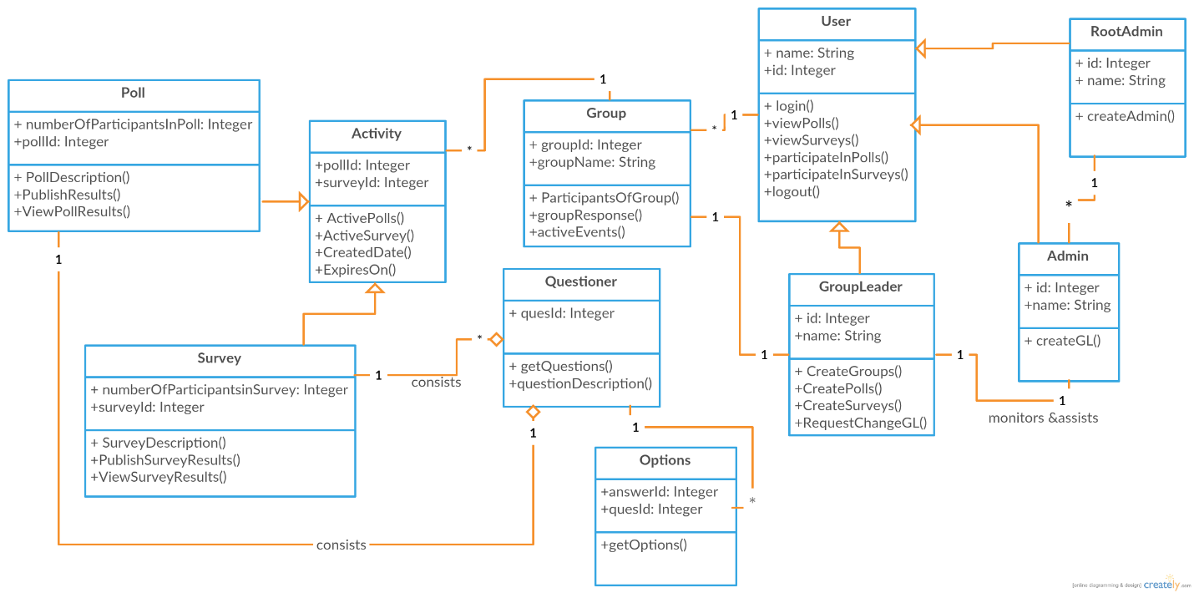Figure 8.1: Class Diagram

* 1. **Sequence Diagram**

Figure 8.2: Sequence Diagram

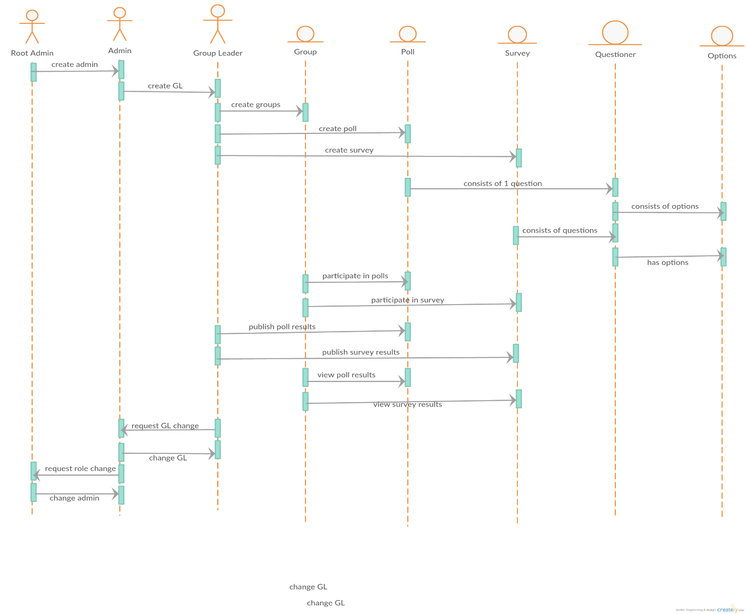

* 1. **Use Case Diagram**

Figure 8.3: Use case diagram

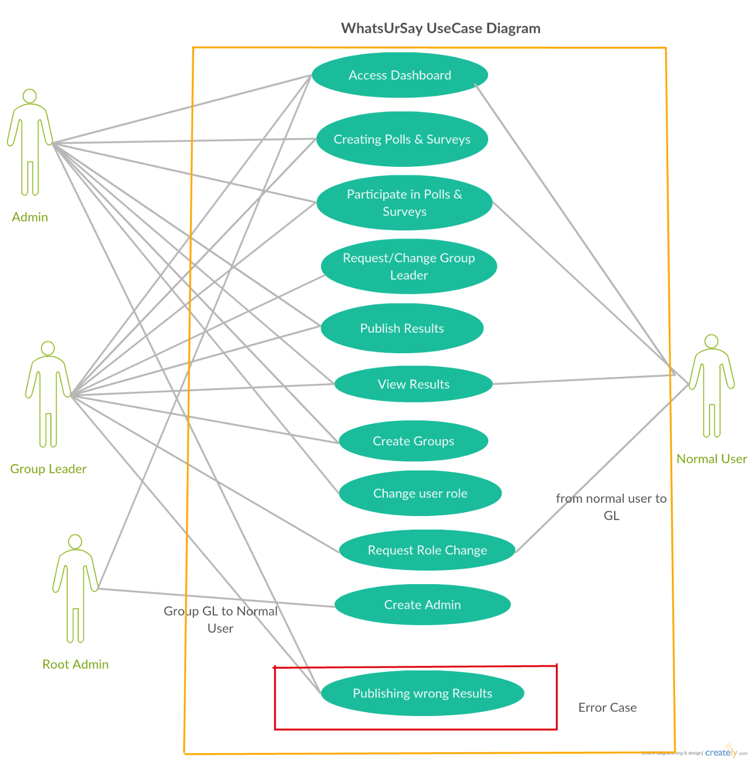

# **Risk Management:**

Table 9.1: Risk Management Plan

|  |  |  |  |
| --- | --- | --- | --- |
| S.NO | Risks | Description | Contingency Plans |
| 1 | Lack of knowledge on technologies used in the project. | We are using technologies and frameworks like AngularJS, ASP.NET MVC and MYSQL which are new to team members. | Get training from online tutorials before working on modules which involves these technologies. |
| 2 | Implementing wide range of features may impact deadlines. | We are implementing wide range of features, even if there is small hindrance during development it will impact deadlines. | In case of missing deadlines, we plan to implement features with high priority and medium priority first. |
| 3 | Time availability conflict for meetings in person. | All team members are not able to make time available for in person meetings. | Meeting are made accessible through  Skype conference calls. If member is not available in person, he or she will attend meeting through skype. |
| 4 | Scope Explosion. | Scope of this project is defined based on requirements and time available. Uncontrolled changes like unexpected issues, misunderstandings and etc. will impact scope of the project. | Reducing the scope of the project without impacting major features. |
| 5 | There are and will be conflicts among team members about design and approaches to follow. | While requirements gathering and elicitation, team member’s opinions were conflicted about design approach and architecture to follow. We are expecting these kind of conflict in future as well (during development and testing phase) | We are and will be scheduling meetings to resolve conflicts among team members. In meetings conflicted opinions are discussed. Team members will be explaining why particular approach or design need to be followed. Approach or design with more advantages will be followed. |

1. **Project Plan**

**Gantt Chart**

Gantt chart is a best way to represent project’s status graphically. It is a kind of bar-chart which is used to schedule a project that helps us to plan, coordinate the tasks and track the specific tasks of the project. Below is the Gantt chart that explains our project schedule:

Figure 10.1: Project Plan Gantt Chart

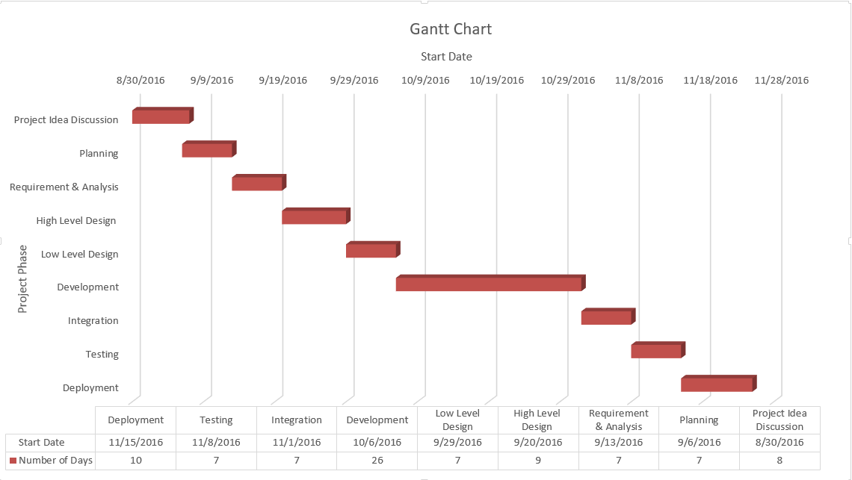

The attributes chosen for preparing the Gantt chart are: start date and project phase. The project phases of our project are: Project Idea Discussion, Planning, Requirement & Analysis, High Level Design, Low level Design, Development, Integration, Testing, and Deployment. From the above Gantt chart, it is clear that none of our project tasks are overlapping and all the tasks will be executed one after the other. The data table has start date and number of days for the completion of project as attributes.

# **Meeting Minutes:**

1. **Meeting on:** 09/14/2016

**Location:** Library

**Time:** 7:15 PM – 10:20 PM

**Team Members/ Attendees**:

Abhinav Bhandaram (Team LEAD)

Rajashekar Goud Korakoppula

Sreedevi Koppula

Kaza Nikhitha

**Topics discussed:**

1. Practiced the deliverable-I presentation.

2. Discussed about the risk management phase.

1. **Meeting on:** 09/20/2016

**Location:** In class 157

**Time:** 11 AM – 11:20 AM

**Team Members/ Attendees**:

Abhinav Bhandaram (Team LEAD)

Rajashekar Goud Korakoppula

Sreedevi Koppula

Kaza Nikhitha

**Topics discussed:**

1. Discussed about who is going to act as the customer for the other groups.

2. Started discussion about the Deliverable II

1. **Meeting on:** 09/22/2016

**Location:** In class 157

**Time:** 10:50 AM – 11:20 AM

**Team Members/ Attendees**:

Abhinav Bhandaram (Team LEAD)

Rajashekar Goud Korakoppula

Sreedevi Koppula

Kaza Nikhitha

**Topics discussed:**

1. Discussed about requirements elicitation.

2. Discussed about project specific risks.

1. **Meeting on:** 09/27/2016

**Location:** In class 157

**Time:** 10:50 AM – 11:20 AM

**Team Members/ Attendees**:

Abhinav Bhandaram (Team LEAD)

Rajashekar Goud Korakoppula

Sreedevi Koppula

Kaza Nikhitha

**Topics discussed:**

1. Discussed about use case and class diagrams for the project.
2. **Meeting on:** 09/29/2016

**Location:** In class 157

**Time:** 10:50 AM – 11:20 AM

**Team Members/ Attendees**:

Abhinav Bhandaram (Team LEAD)

Rajashekar Goud Korakoppula

Sreedevi Koppula

Kaza Nikhitha

**Topics discussed:**

1. Discussed about the Requirement Specification.

2. Discussed about the activity diagram for the project.

1. **Meeting on:** 10/04/2016

**Location:** In class 157

**Time:** 10:50 AM – 11:20 AM

**Team Members/ Attendees**:

Abhinav Bhandaram (Team LEAD)

Rajashekar Goud Korakoppula

Sreedevi Koppula

Kaza Nikhitha

**Topics discussed:**

1. Discussed about the design model for the project.
2. **Meeting on:** 10/06/2016

**Location:** In class 157

**Time:** 10:50 AM – 11:20 AM

**Team Members/ Attendees**:

Abhinav Bhandaram (Team LEAD)

Rajashekar Goud Korakoppula

Sreedevi Koppula

Kaza Nikhitha

**Topics discussed:**

1. Discussed about the functional and non-functional requirements of the project.
2. **Meeting on:** 10/09/2016

**Location:** Library

**Time:** 6:30 PM – 10:15 PM

**Team Members/ Attendees**:

Abhinav Bhandaram (Team LEAD)

Rajashekar Goud Korakoppula

Sreedevi Koppula

Kaza Nikhitha

**Topics discussed:**

1. Discussed and started working on the deliverable-2
2. **Meeting on:** 10/10/2016

**Location:** Library

**Time:** 11:00 AM – 02:00 PM

**Team Members/ Attendees**:

Abhinav Bhandaram (Team LEAD)

Rajashekar Goud Korakoppula

Sreedevi Koppula

Kaza Nikhitha

**Topics discussed:**

1. Worked on the deliverable-2.

# **Progress Report**

**Team: DSEs**

**Members:**

1. Sreedevi Koppula. (Backend/UI Developer)
2. Rajashekhar (Backend Developer)
3. Nikhitha Kaza(Backend/Middle tier Developer)
4. Abhinav Bhandaram. (UI Developer/Architect/Team Lead).

**Tasks**

1. Sreedevi: Functional Requirements, User Interfaces, Minutes of Meetings.
2. Nikhitha: UML Design Documents, Test Plan, Minutes of Meetings.
3. Raj: Non Functional Requirements, Updated Risk Management.
4. Abhinav: Test Plan, System Architecture, Progress Report.

For the deliverable two, the work has been divided as per specified above.

All the items were discussed amongst team members before being carried out.

Functional requirements were identified with the two methods:

1. Interviews (Conducted in class during the elicitation work shop).
2. Brain Storming: All the members of the team were involved in several Brain storming sessions to suggest and finalize the requirements.

For the Non Functional requirements we have taken into account the Scalability, Availability, Performance, Security, and Software quality into account.

Interfaces:

User: List of all the user interfaces for the application has been provided.

External: As our project is a data driven web application, the external resources that need to be used are Web Server, Data Base, .Net Class libraries, AngularJS libraries etc.

Communication: HTTP protocol and SMTP for mailing.

UML Diagrams:

We have included the below diagram:

1. Class Diagram
2. Use Case Diagram
3. Sequence Diagram

Test Plan:

A test plan has been identified for all the Functional Requirements specified in the requirements specification.

Risk Management Plan:

The Risk Management plan has been updated to list out risks specific to our project.

Project Plan:

The Project plan has been updated to reflect the new dates.

Meeting Minutes and Contribution Table:

All the discussions in the meetings amongst team members have been included in the Project Report as meeting minutes. We have also listed the contribution by individual team members.

All the items in the deliverable have been completed well before the deadline.

# **13. Member Contribution Table**

Table 13.1: Member Contribution Table

|  |  |  |  |
| --- | --- | --- | --- |
| Member name | Contribution description | Overall Contribution (%) | Note |
| Sreedevi | Shared thoughts and experiences on previous project’s development.  Discussed on group leadership  Discussed the scope, modules involved and target audience of the project  Discussed risks involved in the project, high level project plan, project timeline, GANTT and PERT charts.  Discussed project’s directory structure, web pages UI layout and low level requirements.  Discussed about the manager’s report. Discussed about the re-evaluation of risk management phase.  Discussed about the pert and Gantt chart.  Deliverable-I preparation.  Preparation of the presentation.  Discussed the risks involved in our project and identified the contingency plans  Discussed about who is going to act as the customer for the other groups  Discussed requirements elicitation.  Discussed project specific risks  Discussed about use case and class diagrams for the project.  Discussed about the Requirement Specification.  Discussed about the activity diagram for the project  Discussed about the design model for the project.  Discussed about the functional and non-functional requirements of the project.  Discussed and started working on the deliverable-2.  Worked on the Functional Requirements for deliverable-2. | 25 | NA |
| Nikhitha | Shared thoughts and experiences on previous projects development.  Discussed on group leadership, scope and target audience of the project  Discussed risks involved in the project, high level project plan, project timeline, GANTT and PERT charts.  Discussed project’s directory structure, web pages UI layout and low level requirements  Discussed about the manager’s report.  Discussed about the re-evaluation of risk management phase.  Discussed about the pert and Gantt chart.  Deliverable-I preparation.  Preparation of the presentation  Discussed the risks involved in our project and identified the contingency plans  Discussed about who is going to act as the customer for the other groups  Discussed requirements elicitation.  Discussed project specific risks  Discussed about use case and class diagrams for the project.  Discussed about the Requirement Specification.  Discussed about the activity diagram for the project  Discussed about the design model for the project.  Discussed about the functional and non-functional requirements of the project.  Discussed and started working on the deliverable-2.  Worked on the UML diagrams for deliverable-2 | 25 | NA |
| Rajashekar | Shared thoughts and experiences on previous projects development  Discussed on group leadership, scope and modules of the project.  Discussed risks involved in the project, high level project plan, project timeline, GANTT and PERT charts.  Discussed project’s directory structure, web pages UI layout and low level requirements  Discussed about the manager’s report.  Discussed about the re-evaluation of risk management phase.  Discussed about the pert and Gantt chart.  Deliverable-I preparation.  Preparation of the presentation  Discussed the risks involved in our project and identified the contingency plans  Discussed about who is going to act as the customer for the other groups  Discussed requirements elicitation.  Discussed project specific risks  Discussed about use case and class diagrams for the project.  Discussed about the Requirement Specification.  Discussed about the activity diagram for the project  Discussed about the design model for the project.  Discussed about the functional and non-functional requirements of the project.  Discussed and started working on the deliverable-2.  Worked on the Non-Functional Requirements and risks management for deliverable-  2. | 25 | NA |
| Abhinav | Shared thoughts and experiences on previous projects development  Discussed on group leadership  Explained the overview of ‘Online Voting Application’  Proposed MVC architecture  Discussed technologies to be used for project development  Discussed risks involved in the project, high level project plan, project timeline, GANTT and PERT charts.  Discussed project’s directory structure, web pages UI layout and low level requirements  Discussed about the manager’s report.  Discussed about the re-evaluation of risk management phase.  Discussed about the pert and Gantt chart.  Deliverable-I preparation.  Preparation of the presentation  Discussed the risks involved in our project and identified the contingency plans  Discussed about who is going to act as the customer for the other groups  Discussed requirements elicitation.  Discussed project specific risks  Discussed about use case and class diagrams for the project.  Discussed about the Requirement Specification.  Discussed about the activity diagram for the project  Discussed about the design model for the project.  Discussed about the functional and non-functional requirements of the project.  Discussed and started working on the deliverable-2.  Worked on the Architecture, Test plan and progress report for deliverable-2 | 25 | NA |

**Appendix A:**

This section lists out the identified terms used in our application, the knowledge of these terms would help in understanding the document better:

1. **Poll:** Record the opinion or vote of. [1]
2. **Survey:** Surveys are a method of gathering information from individuals. [2]

**References:**

1. **Google Definitions:** [**https://www.google.com/webhp?sourceid=chrome-instant&ion=1&espv=2&ie=UTF-8#q=what+is+a+poll**](https://www.google.com/webhp?sourceid=chrome-instant&ion=1&espv=2&ie=UTF-8#q=what+is+a+poll)**, Accessed: 10/11/2016**
2. **Hr-survey.com:** [**http://www.hr-survey.com/WhatIs.htm**](http://www.hr-survey.com/WhatIs.htm)**, Accessed: 10/11/2016**
3. **Creately.com:** [**https://creately.com**](https://creately.com)**, Accessed: 10/9/2016**
4. **Class Lectures.**